**Phase 1**

**Course-end Project 1**

**Project Objective :**

As a Full Stack Developer, design and develop an airline booking portal named as FlyAway. Use the GitHub repository to manage the project artifacts.

**Developer Details :**

**Seelam Sindhuja**

**Email: ssindhuja@teksystems.com**

**Emp Id : 10840**

**Project Overview :**

The project is designed to provide user ability to book flight tickets based on their requirements. This portal can be controlled by using admin login.

**Project Capability :**

The project is capable of booking tickets by the user based on available flights. User can do registration by giving some basic details and after they can confirm their tickets by doing payment.

**Project Appearance :**

Appearance of the first screen of the project is the welcome screen which has two options one for flight booking and other for admin login. Users can book tickets through this flight booking option. Admin login enables to change password and can see list of full details of flights.

**User Interactions :**

User once select flight booking they are direct to a page to enter date, source, destination and number of persons, based on these parameters available flights are displayed. User can select from displayed available flights and on selection they are asked to enter basic details and directed to payment page. After payment flight details and passenger information displayed as confirmation page.

**Project Git hub link :**

https://github.com/SindhujaSeelam/ServletDemos/tree/main/Phase%202%20project

**Sprint Planning :**

I have divided project into 3 sprints.

Sprint 1:

In sprint 1 I have configured all the requirements of the project at first and then designed rough outline of the project. I have first started to design SQL tables namely flight table with parameters source, destination, date and price, passenger table with firstname, lastname, phone, email and finally admin login credentials table.

Sprint 2:

In sprint 2 I have designed the first screen of the project after its execution which consists of welcome note and two options for flight booking and admin login . Created servlets to accept data from JSP pages and perform SQL operations to insert and update data in database.

Sprint 3:

In sprint 3 I have implemented all front end designing to have easy interaction for the users and also coded all the exceptions that can happen while entering data in the portal and made connection between all the servlets and JSP pages.

Admin username : Sindhuja

Admin password : 1234

Concepts Used:

* Servlets
* JSP pages
* Resource pooling
* SQL queries
* Database connection statements
* Collections(Array List)
* Conditional Statements
* While Loop

**Flowchart of the program**

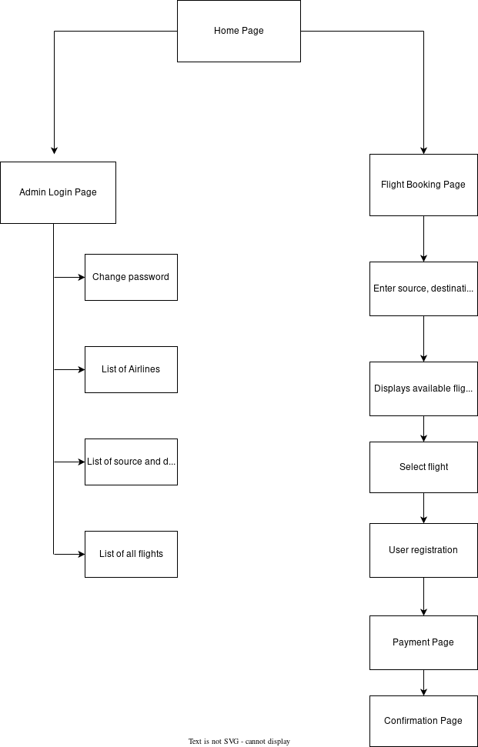

Algorithm of Application:

Step 1: START

Step 2: run main HTML page(home.html)

Step 3: Displays two options

Flight Booking

Admin Login

Step 4: Enter source, destination, date and number of persons

Step 5 : Displays available flights on that date

Select one flight to book

Step 6: User registration

Enter below details

Firstname, lastname, phone

Email, age

Step 7: Payment page

Enter bank account details

Step 8: Confirmation Page

Step 9: STOP